
SIMATS ENGINEERING
ASSESSMENT TOOL 2
NAME: SANDHIYA K
REG NO:192521378
COURSE NAME: COMPUTER NETWORKS
COURSE CODE: CSA07​ | ​ | ​ | ​ | ​

COURSE OUTCOME COVERED
CO5: Measure network performance using key metrics with simulation tools.
(BL4,BL5)
Assessment Tool Weightage: 30%
Annexure A
​ | ​ | ​ | ​ | ​

Pseudocode Writing Task (Algorithm Design)
1.​ In a network simulation using Cisco Packet Tracer, a student records total
data received as 8000 bits in 4 seconds and observes that 200 packets were
sent while 180 packets were received. Write a pseudocode algorithm to
calculate the network throughput in bits per second and the packet loss
percentage based on the given values. The algorithm should include
validation to ensure that time and total packets sent are not zero to avoid
errors. It should display both the throughput and packet loss results clearly.
Add logic to classify the network as Efficient if throughput is greater than
1500 bps and packet loss is less than 10%, otherwise classify it as Inefficient.
Finally, ensure the algorithm outputs a complete summary of the network
performance based on the calculated metrics.
2.​ An organization has multiple network links connecting its branches. The
administrator wants to monitor bandwidth utilization and identify overloaded
links. Write a pseudocode algorithm that periodically collects the bandwidth
usage of each network link and stores the values in an array or list. Use a
loop to continuously monitor all links. Add conditions to detect when
bandwidth utilization exceeds 80% and recommend switching traffic to a
backup link. Explain how this algorithm supports efficient bandwidth
management and prevents network congestion.
3.​ A company has six branch offices connected through multiple network links.
Each link has different bandwidth, delay, and utilization values, which
change throughout the day. The network administrator wants to continuously


identify the best communication path between the headquarters and each
branch based on overall link quality rather than just the shortest
distance.Write a pseudocode algorithm that periodically collects the
bandwidth, delay, and utilization of every network link and stores the values
in suitable arrays or lists. Use a loop to repeat the monitoring process at
regular intervals. Calculate a link quality score for each path using the
collected metrics and select the path with the highest score. Include
conditions to detect when a link becomes overloaded or fails, automatically
selecting an alternate path and generating an alert for the administrator.
Explain how your algorithm improves network reliability, routing efficiency,
and fault tolerance while adapting to changing network conditions.
RUBRICS FOR CALCULATION
Criteria | Weightag  e | Level 4 –  Exemplary | Level 3 –  Proficient | Level 2 –  Developing | Level 1 –  Beginning
Problem  Understanding | 20% | Identifies all  inputs, outputs, constraints  accurately | Minor  missing  elements | Partial  understandin  g | Incorrect  interpretatio  n
Algorithm  Design | 30% | Complete,  correct, and  logically sound solution | Minor  logical gaps | Partially  correct logic | Incorrect  approach
Use of Control Structures | 20% | Efficient and  appropriate use of loops,  conditions,  functions/modu  les | Minor  inefficiencie  s | Limited or  basic usage | Incorrect or  missing  constructs
Pseudocode  Structure | 10% | Well-structured , clear,  consistent  format, easy to follow | Mostly clear  with minor  issues | Difficult to  follow in  parts | Poorly  structured  and unclear
Completeness | 20% | Handles all  cases;  optimized  approach | Handles  most cases;  reasonable  efficiency | Handles  basic cases  only | Incomplete  or  inefficient


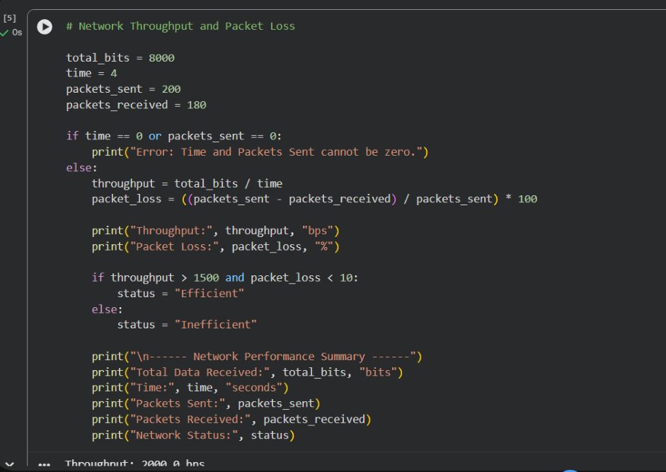
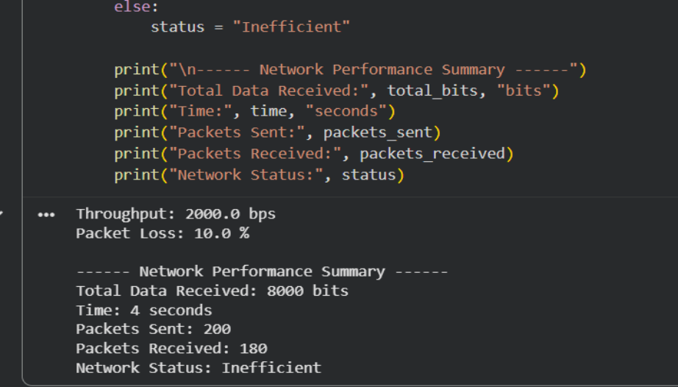
1.​Pseudocode: Network Throughput and Packet Loss
Calculation


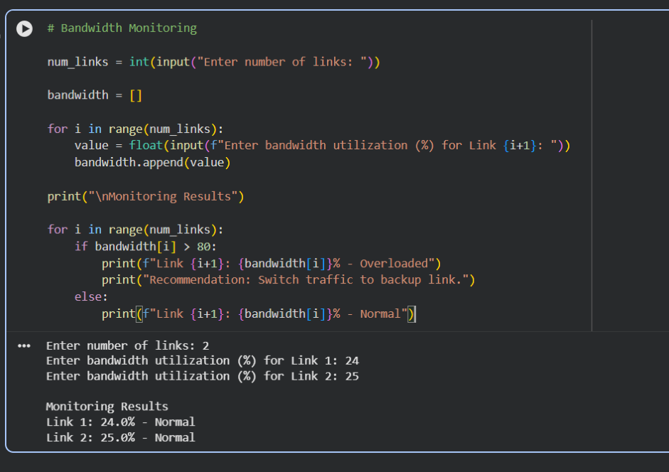
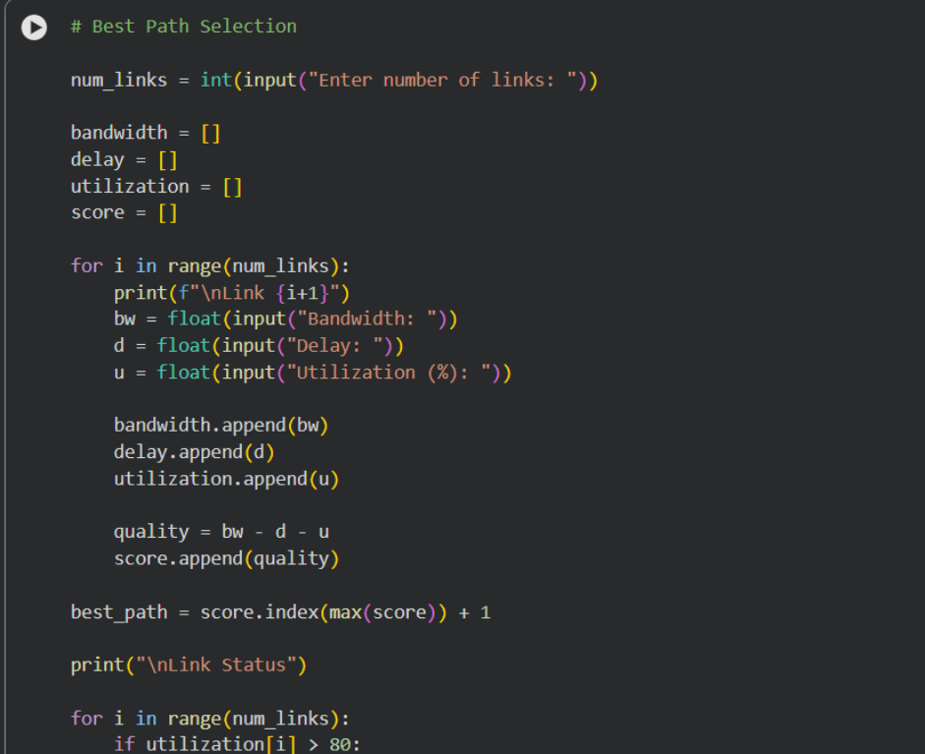
2.​Pseudocod: Bandwidth Utilization Monitoring
3.​Pseudocode: Best Path Selection Based on Link Quality


